**ASSIGNMENT 16**

**STEPS PERFORMED ON BASH SCRIPTING**

# **INDEX**

|  |  |  |
| --- | --- | --- |
| **SL NO** | **TOPIC** | **PAGE NO** |
| 1. | Summary report on different steps performed on Bash Scripting CTF | 2-3 |
|  |  |  |

# **Topic: STEPS PERFORMED ON BASH SCRIPTING (TRYHACK ME)**

ASSIGNMENT 16(DAY 18) Date:16-07-2022

1. **Summary report on different steps performed on Bash Scripting CTF**

**Step 1:**

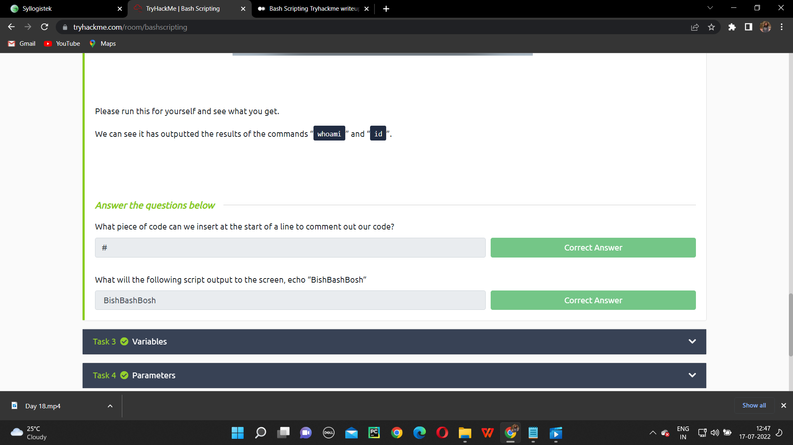

**Step 2:**

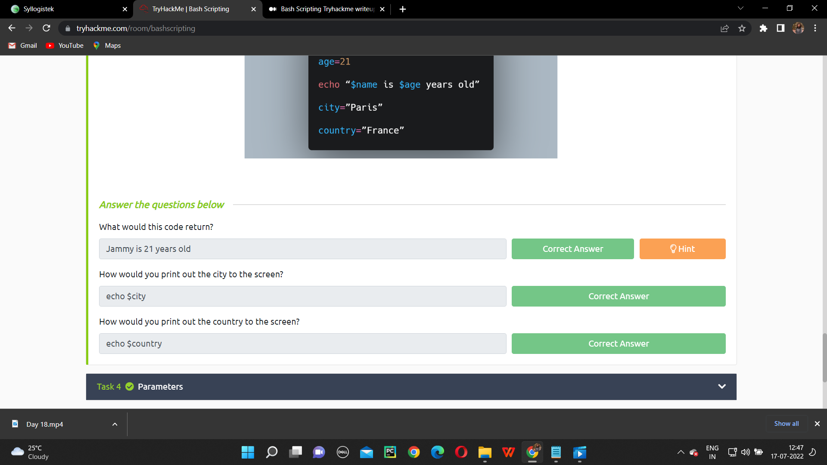

**Step 3:**

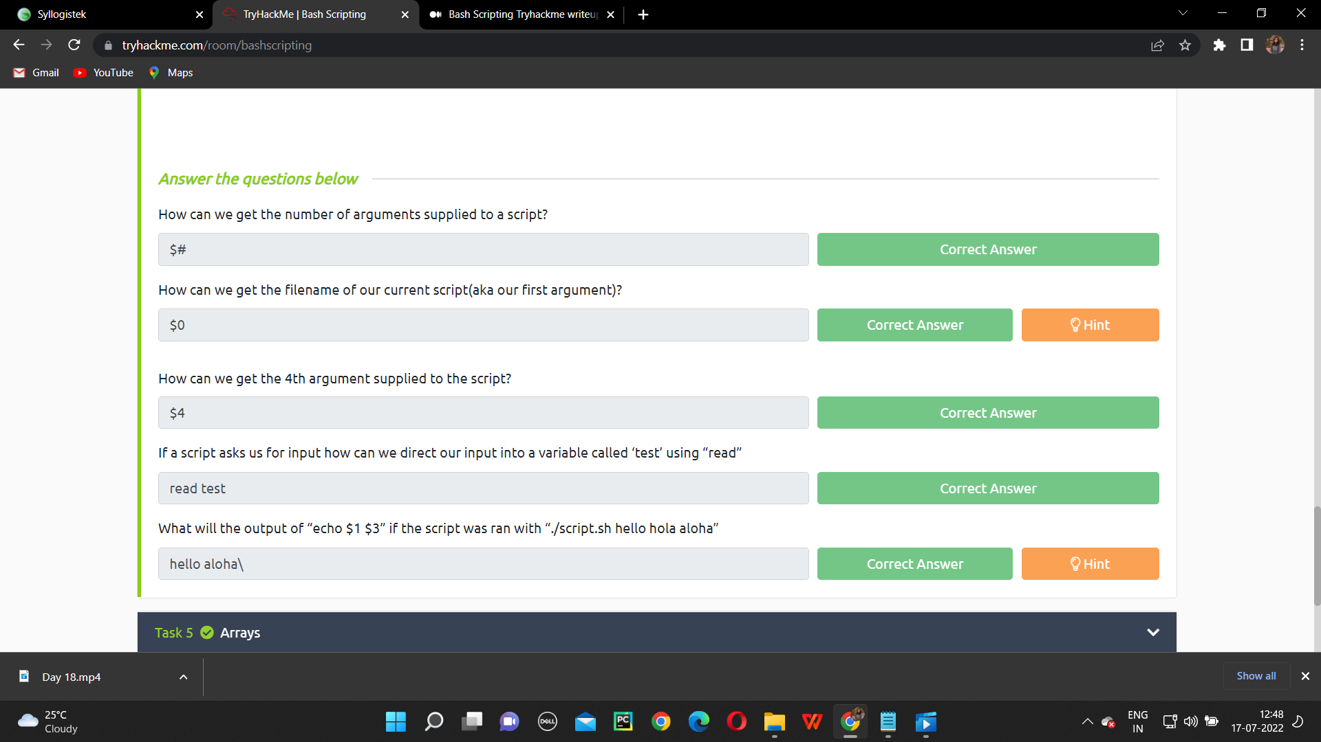

**Step 4:**

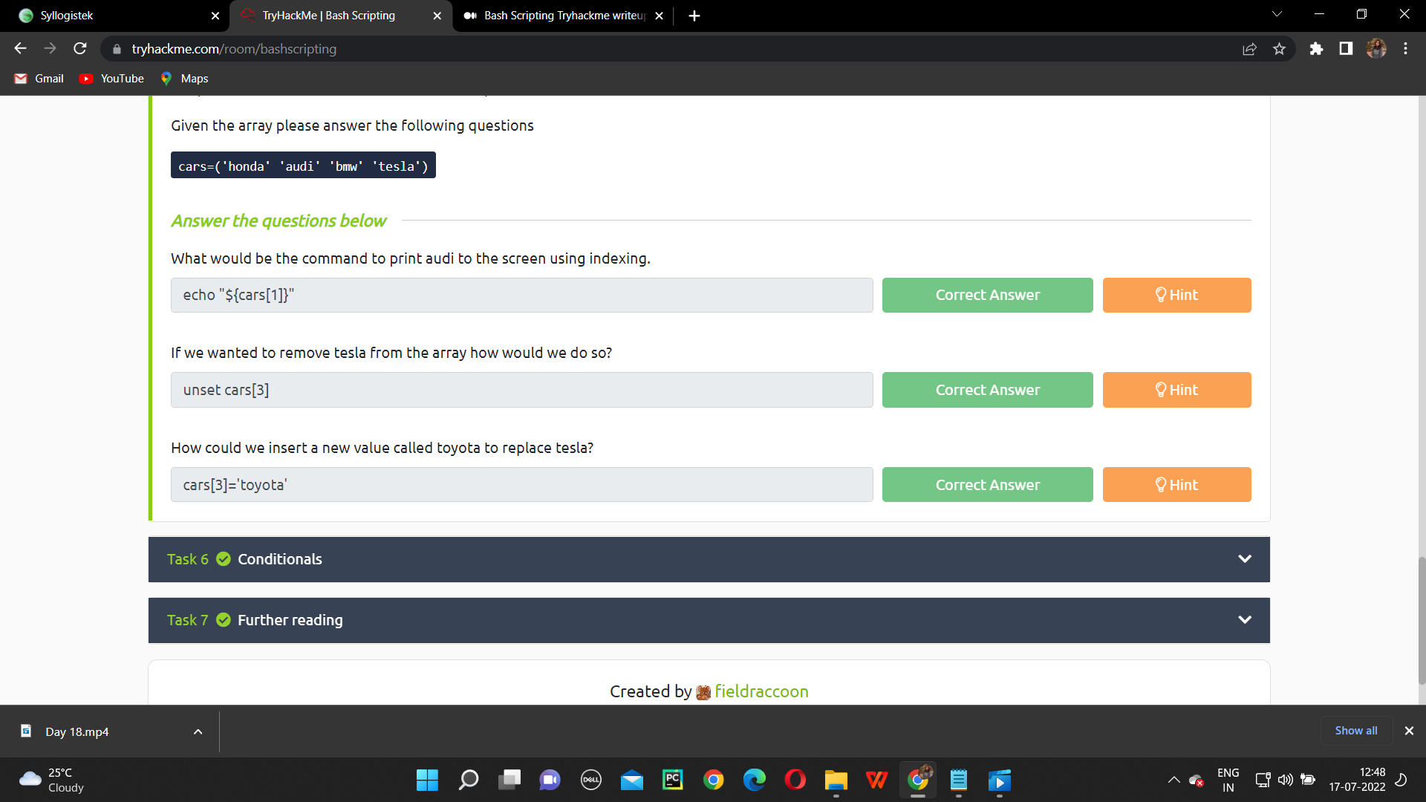

**Step 5:**

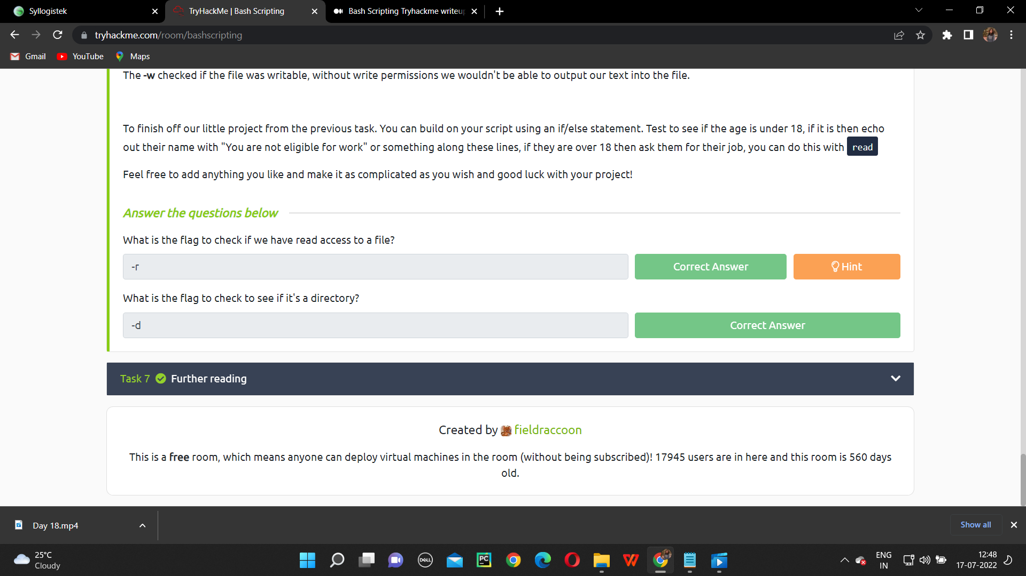

**NAME: I PRASANTI**

**SIC: 20BCEA56**

**BRANCH: CEN**